

Braude College

**OptiVision:**

**Advanced Screening for Early Detection of Eye Health Issues**

**24-2-D-23**

Tameer Amer 322836388

Redan Ganim 209003474

Mentor: Dr. Natali Levi

**Abstract**

OptiVision is a desktop application designed to provide accessible and user-friendly tools for the early detection of vision impairments. With millions of people worldwide affected by undiagnosed vision issues, there is a pressing need for a solution that allows users to conduct preliminary vision tests from the comfort of their homes. OptiVision addresses this need by incorporating a series of scientifically validated tests, including visual acuity, color vision, contrast sensitivity, blur detection, and field of vision assessments.

The application guides users through these tests, ensuring accurate results through an initial screen calibration process. Test results are securely stored in a database, allowing users to track their vision health over time. The system provides clear and actionable recommendations based on the results, encouraging users to seek professional eye care when necessary.

OptiVision operates by utilizing hardware inputs such as the user's monitor, mouse, and keyboard. The user first performs a screen calibration to ensure test accuracy, followed by a guided sequence of vision tests. Each test is interactive and tailored to measure specific aspects of vision health. After completing the tests, the system processes the data and displays a detailed report, highlighting any areas of concern. Users can revisit past results and monitor changes in their vision, allowing for early detection of potential issues. By making vision health assessments more accessible, OptiVision aims to reduce the number of undiagnosed cases and promote early intervention, ultimately improving the quality of life for individuals with potential vision impairments.

Table of Contents

1.Introduction 5

2. Related Work 6

2.1 Symptom Detection 7

2.1.1 Visual Acuity 7

2.1.2 Color Vision: 8

2.1.3 Environmental Factors: 8

2.1.4 Eye Movement and Tracking: 8

2.1.5 Contrast Vision 8

2.1.6 Blur Check 9

2.1.7 Watch the Dot Test 9

2.2 Gender Differences 9

2.3 Treatment 9

2.3.1 Corrective Lenses 9

2.3.2 Behavioral Adjustments 10

2.4 Risks 10

2.4.1 Risks of Symptom Detection 10

2.4.2 Risks of Symptom Development 10

3.Expected Achievements 11

3.1 Outcomes 11

3.2. Criteria for Success: 11

4. The Process 11

4.1 Research - Visual Acuity, Color Vision, and Additional Vision Tests 11

4.1.1 Challenges - Visual Acuity, Color Vision, and Additional Vision Tests 12

4.2 Research - Contrast Vision and Blur Detection 12

4.2.1 Challenges - Contrast Vision and Blur Detection 12

4.3 Research - Field of Vision Testing 13

4.3.1 Challenges - Field of Vision Testing 13

4.4 Development 14

5. The Product 15

5.1 System Requirements 15

5.1.1 Functional: 15

5.1.2 Non-Functional: 16

5.2 Architecture Diagram 17

5.2.1 Explanations: 18

5.3 Diagrams 20

5.3.1 Activity Diagram 20

5.3.2 Class Diagram 21

5.3.3 Use-Case Diagram 22

5.4 Algorithms: 23

5.4.1 Visual Acuity Test: 23

5.4.2 The Contrast Test: 25

5.4.3 Color Vision Test: 26

5.4.4 Blur Detection Test: 27

5.4.5 Field of Vision Test: 28

5.5 Screen Calibration: 29

6. Evaluation 29

6.1 System Functionality 30

6.2 User Experience 31

6.3 Vision Test Accuracy 31

7. References 34

7.1 GitHub Link: 34

7.2 Academic References: 34

# 1.Introduction

The problem we aim to solve is the widespread issue of undiagnosed vision impairment. Vision impairment affects over 2.2 billion people globally, with at least 1 billion of these cases being preventable or yet to be addressed. The leading causes include refractive errors and cataracts, both of which are treatable conditions that, if left unaddressed, significantly impact individuals' quality of life, educational and employment opportunities, and overall well-being. The economic burden of untreated vision impairment is substantial, costing the global economy an estimated $411 billion annually​ ([World Health Organization (WHO)](https://www.who.int/news-room/fact-sheets/detail/blindness-and-visual-impairment))​​ ([UCL](https://www.ucl.ac.uk/news/2021/feb/over-one-billion-people-have-untreated-vision-impairment))​.

Globally, at least 2.2 billion people suffer from near or distance vision impairment. In nearly half of these cases, the impairment could have been prevented or has yet to be addressed. The primary conditions contributing to distance vision impairment or blindness include cataracts (94 million), refractive errors (88.4 million), age-related macular degeneration (8 million), glaucoma (7.7 million), and diabetic retinopathy (3.9 million)​ ([World Health Organization (WHO)](https://www.who.int/news-room/fact-sheets/detail/blindness-and-visual-impairment))​. Visual impairment, defined as the limited functional ability of an individual's vision system, prevents individuals from performing daily activities and cannot be fully corrected by conventional means.

According to the World Health Organization (WHO), as of 2014, there were approximately 285 million visually impaired people worldwide, with 39 million being blind and 246 million suffering from low vision. Additionally, 82% of those who are blind are aged 50 and older. With an aging population, the number of people at risk for visual impairment due to age-related eye diseases is expected to increase​ ([UCL](https://www.ucl.ac.uk/news/2021/feb/over-one-billion-people-have-untreated-vision-impairment))​.

Currently, the primary solutions for diagnosing and treating vision impairment involve regular eye exams conducted by ophthalmologists or optometrists. These exams are crucial for detecting common eye conditions like myopia, hyperopia, astigmatism, cataracts, glaucoma, and diabetic retinopathy. Despite the availability of these services, many barriers prevent people from accessing them. These barriers include high costs, lack of awareness, inadequate health insurance, limited availability of eye care professionals, especially in low-income and rural areas, and logistical challenges such as transportation​ ([UCL](https://www.ucl.ac.uk/news/2021/feb/over-one-billion-people-have-untreated-vision-impairment))​​ ([BioMed Central](https://bmcophthalmol.biomedcentral.com/articles/10.1186/s12886-022-02459-y))​.  
  
We plan to develop a user-friendly mobile application that enables users to perform basic vision tests at home. This application will utilize standard vision screening techniques and incorporate artificial intelligence to analyze the results, providing users with preliminary assessments of their vision health. The app will also offer recommendations for further action, such as visiting an eye care professional if potential issues are detected. By making vision screening more accessible and convenient, we aim to reduce the number of undiagnosed cases of vision impairment and encourage timely intervention​ ([UCL](https://www.ucl.ac.uk/news/2021/feb/over-one-billion-people-have-untreated-vision-impairment))​​ ([BioMed Central](https://bmcophthalmol.biomedcentral.com/articles/10.1186/s12886-022-02459-y))​.

# 2. Related Work

*Available Solutions****:***

* **Comprehensive Eye Examination**: Conducted by optometrists or ophthalmologists, these examinations include a series of tests to assess visual acuity, detect refractive errors, and evaluate overall eye health. This method ensures a thorough and accurate diagnosis.
* **School-Based Vision Screenings**: Implemented by teachers or school nurses, these screenings involve basic eye tests to identify students who may have vision problems and need further professional evaluation.
* **Digital Tools and Apps**: Designed for preliminary vision screening at home, these tools offer tests such as the Snellen chart and color vision tests. They provide an accessible way to detect potential vision issues early and suggest when to seek professional care.
* **Questionnaires**: Tools like the Visual Function Questionnaire (VFQ) collect detailed information about an individual's visual experience in daily activities. They help identify how vision impairments affect quality of life and provide insights for further assessment.
* **Contrast Vision Check**: This test measures the ability to distinguish between different shades of gray. It helps in detecting problems that may not be identified in standard visual acuity tests and is crucial for diagnosing conditions like cataracts or macular degeneration.
* **Blur Check**: This test involves looking at images or text that progressively become blurrier. It helps in identifying issues with focusing and can indicate refractive errors such as myopia or hyperopia.
* **Watch the Dot Test**: Also known as the Amsler grid test, this checks for issues in the field of vision, such as blind spots or distortions. It is particularly useful for detecting macular degeneration and other retinal problems.

## 2.1 Symptom Detection

Over the years, doctors and medical professionals have developed various methodologies to detect potential eye vision impairments. These methodologies often involve standardized tests such as the Snellen chart for visual acuity and the Ishihara plates for color vision. Educating individuals about common eye conditions and their symptoms is highly recommended, as this increases the likelihood of early detection and treatment.

### 2.1.1 Visual Acuity

Visual acuity tests, like the Snellen chart, measure how well a person can see at various distances. Common symptoms indicating a need for such tests include blurred vision, difficulty reading, and trouble recognizing faces from a distance. However, visual acuity issues can often be comorbid with other eye conditions such as astigmatism or cataracts. Approximately 60% of individuals with vision problems have other related impairments. Therefore, a comprehensive eye examination by a trained professional is often required for an accurate diagnosis.

### 2.1.2 Color Vision:

Color vision testing, such as the use of Ishihara plates, helps identify color blindness. This condition affects the ability to distinguish between certain colors, commonly red and green. Environmental factors, such as exposure to certain chemicals or medications, can also impact color vision. Understanding these factors is crucial for accurate diagnosis and management.

### 2.1.3 Environmental Factors:

Environmental variables play a significant role in the development of eye conditions. Exposure to toxins, smoking, and socio-economic status can influence eye health. Additionally, lifestyle choices, such as prolonged screen time, can lead to digital eye strain. Recognizing these factors helps in understanding the broader context of vision impairments.

### 2.1.4 Eye Movement and Tracking:

Studies have shown that eye movement and tracking tests can provide valuable insights into visual function. Tests like the "Fixation Task" and "Continuous Inhibition and Selective Attention" measure how well the eyes can maintain focus and respond to visual stimuli. These tests are useful in diagnosing conditions like nystagmus and other ocular motility disorders.

### 2.1.5 Contrast Vision

Contrast vision tests measure the ability to distinguish between different shades of gray. This is essential for detecting problems that may not be identified in standard visual acuity tests and is crucial for diagnosing conditions like cataracts or macular degeneration.

### 2.1.6 Blur Check

Blur checks involve looking at images or text that progressively become blurrier. This test helps in identifying issues with focusing and can indicate refractive errors such as myopia or hyperopia.

### 2.1.7 Watch the Dot Test

Also known as the Amsler grid test, this checks for issues in the field of vision, such as blind spots or distortions. It is particularly useful for detecting macular degeneration and other retinal problems.

## 2.2 Gender Differences

Studies have found that eye conditions can manifest differently in males and females, necessitating tailored approaches for detection and treatment. For instance, males may be more prone to color blindness, while females might report more symptoms related to digital eye strain. Understanding these differences ensures more accurate diagnosis and effective intervention.

## 2.3 Treatment

Educating individuals about common eye conditions is crucial for effective treatment. Early referral to eye care professionals, including optometrists and ophthalmologists, is essential. Studies have shown that a multimodal approach, combining corrective lenses, medication, and lifestyle adjustments, is often the most effective treatment for vision impairments.

### 2.3.1 Corrective Lenses

Prescription glasses or contact lenses are commonly used to correct refractive errors like myopia, hyperopia, and astigmatism. The correct prescription is determined through a series of tests and measurements conducted by eye care professionals.

### 2.3.2 Behavioral Adjustments

Behavioral adjustments, such as reducing screen time, improving lighting conditions, and taking regular breaks during visual tasks, can help alleviate symptoms of digital eye strain and other vision-related issues. Educating individuals on these practices is a key component of managing eye health.

## 2.4 Risks

There are potential risks associated with both the presence of eye vision impairments and the process of diagnosing them.

### 2.4.1 Risks of Symptom Detection

One of the major risks is misdiagnosis, which can occur due to the overlap of symptoms with other conditions. For instance, headaches and eye strain can be symptoms of both vision problems and other health issues like migraines or tension headaches. Long-term observation and comprehensive testing are necessary for accurate diagnosis.

### 2.4.2 Risks of Symptom Development

Lack of awareness and delayed treatment can exacerbate vision problems. Early detection and management are crucial to prevent worsening of conditions. Additionally, underlying health issues, such as diabetes, can significantly impact eye health, highlighting the need for regular check-ups and integrated care.

By addressing these aspects comprehensively, our project aims to provide an accessible, effective, and user-friendly tool for early detection and management of eye vision impairments.

# 3.Expected Achievements

## 3.1 Outcomes

We aim to make sure that the patients detect sight loss at an early stage in life by providing an accessible and user-friendly way for eye vision impairment detection. Currently, such assessments often require professional intervention and can be cost-prohibitive for many individuals. Our software aims to democratize eye health screening by offering digital visual acuity and color vision tests that can be conducted at home. Our program is built on popular approaches like the Snellen chart and Ishihara plates, which help our clients conduct basic eye assessments using simple tools such as a computer monitor or smartphone. Additionally, we incorporate tests for contrast vision, blur detection, and field of vision checks, such as the Amsler grid. This will provide useful information about the individual’s color vision, visual acuteness, and other potential vision issues, thus determining whether additional medical examination is necessary. Consequently, by taking early steps in managing their optical health, people are able to address such problems before they become worse.

## 3.2. Criteria for Success:

* Implementation of scientifically validated and credible tests.
* User-friendly interface that facilitates easy navigation and test administration.
* Clear and comprehensible test results with actionable insights.
* Provision of useful tips and recommended next steps based on test outcomes.
* Accurate measurement of visual acuity and color vision.
* Short and concise tests that require minimal time to complete.

# 4. The Process

## 4.1 Research - Visual Acuity, Color Vision, and Additional Vision Tests

To create reliable tests for visual acuity, color vision, contrast vision, blur detection, and field of vision, we reviewed existing studies and technologies. This included digital versions of the Snellen chart for visual acuity, Ishihara plates for color vision, and other tests for contrast sensitivity, blur detection, and field of vision issues.

### 4.1.1 Challenges - Visual Acuity, Color Vision, and Additional Vision Tests

Making these tests work well on a digital platform involves several challenges.

Hardware:

Display Quality: The quality of the user’s screen can affect the test results.

Screen Size: Different screen sizes can impact how well users perform on the tests.

Technical:

Device Compatibility: The software must work on various devices with different screen sizes and resolutions.

Calibration: Ensuring the tests are accurate on different devices.

User Environment: Lighting and screen glare can affect test outcomes, so users need guidance on the best environment for testing.

## 4.2 Research - Contrast Vision and Blur Detection

We researched how to effectively test for contrast vision and blur detection. This included looking at how these aspects of vision are measured and reviewing existing digital tools for these tests.

### 4.2.1 Challenges - Contrast Vision and Blur Detection

There are several obstacles to creating accurate contrast vision and blur detection tests.

Hardware:

Screen Contrast Ratio: The contrast ratio of the user’s screen can affect the test’s effectiveness.

Blur Simulation: Making sure blur is accurately detected on screens with different resolutions.

Technical:

Software Calibration: Adjusting the software to ensure consistent results on various devices.

Environmental Factors: Lighting and reflections can affect the tests, so users need advice on optimal testing conditions.

## 4.3 Research - Field of Vision Testing

We studied field of vision tests, like the "watch the dot" test (Amsler grid), to detect issues such as macular degeneration. We looked at existing digital implementations to understand the best methods.

### 4.3.1 Challenges - Field of Vision Testing

Creating effective field of vision tests digitally involves specific challenges.

Hardware:

Display Size and Quality: Ensuring the test patterns are displayed correctly on different screens.

User Interaction: Finding reliable ways for users to report what they see during the test.

Technical:

Software Precision: Developing software that accurately tracks user responses.

Consistency: Ensuring the tests are consistent across different devices and environments.

## 4.4 Development

Agile Development with Iterative Testing

We will use the Agile method, focusing on iterative development and testing. This fits well with our project since each test (like visual acuity or color vision) can be developed and tested separately. This allows for quick feedback and continuous improvement.

Here's how we’ll develop the project using Agile:

Test Implementation: We will develop each test (visual acuity, color vision, contrast vision, blur check, and field of vision) in short cycles called sprints. Each sprint will focus on building a small part of the test, allowing for quick testing and feedback.

Data Integration and Comparison: After developing a test, we’ll collect data and compare it with our research findings. This helps us check if the tests are effective in identifying vision problems.

Iterative Testing and Evaluation: After each sprint, we’ll thoroughly test the software to ensure everything works as expected. We’ll also evaluate the overall product against predefined success criteria.

Agile Iteration and Improvement: If we find any issues or areas for improvement during testing or evaluation, we’ll address them in future sprints. This iterative approach allows us to continuously refine the software and ensure it meets user needs.

Using Agile methodology, we can ensure a flexible and efficient development process, allowing us to adapt to new findings, refine functionalities, and deliver a valuable tool for early detection and management of eye vision impairments.

# 5. The Product

## 5.1 System Requirements

### 5.1.1 Functional:

|  |  |
| --- | --- |
| 1 | The system will prompt the user to calibrate screen dimensions. |
| 2 | The system will use a computer monitor or smartphone screen. |
| 3 | The system will use a keyboard and mouse for user input. |
| 4 | The system will include a series of eye tests such as visual acuity, color vision, contrast vision, blur check, and field of vision. |
| 5 | The system will have a database to store test data. |
| 6 | The system will analyze the collected data to detect potential vision impairments. |
| 7 | The system will display test results and analysis in the application. |
| 8 | The system will offer a questionnaire to gather additional information about the user's visual experience. |
| 9 | The system will provide tips and recommendations based on the test results. |
| 10 | The system will allow users to take the tests and view results at home. |
| 11 | The system will provide clear and easy-to-understand instructions for each test. |
| 12 | The system will support different screen resolutions and sizes. |
| 13 | The system will ensure data privacy and security. |

### 5.1.2 Non-Functional:

|  |  |
| --- | --- |
| 1 | The interface will be easy to use and navigate. |
| 2 | The system will be compatible with various monitors and smartphone screens. |
| 3 | Tests will be designed to take a minimal amount of time. |
| 4 | The analysis and results will be straightforward and easy to understand. |
| 5 | The system will provide clear instructions and recommendations based on test outcomes. |
| 6 | The system will maintain high data security and user privacy standards. |

## 5.2 Architecture Diagram

5.2 Application Architecture Diagram

### 5.2.1 Explanations:

* **Register**

This is the starting point for new users. When someone signs up, their details (like username and password) are securely stored in the database. This ensures that the next time they use the app, they can log in and access their personalized data.

* **Login**

When returning users log in, the app checks their credentials against what’s stored in the database. If everything matches, they’re granted access to their account and can proceed to the home page. This step is crucial for keeping user data secure.

* **Show Home Page**

After logging in, users are taken to the home page, which acts as the central hub of the app. From here, they can navigate to different features like performing vision tests or viewing their results. It’s the main starting point once they’re logged in.

* **Conduct Screen Calibration**

Before any vision tests are conducted, the app ensures the screen is calibrated correctly. This step helps maintain accuracy in the tests by making sure the display settings (like size and resolution) are appropriate.

* **Perform Vision Tests**

This is where users take various vision tests. The results of these tests are saved in the database under "Save Test Results," ensuring that they can be reviewed later. This is the core functionality of the OptiVision system.

* **Process Test Data**

Once the tests are complete, the app processes the data to generate insights. This might involve calculations, comparisons, or other forms of data analysis. The app may retrieve historical test data from the database to help with this processing.

* **Show Results and Recommendations**

Finally, the processed results are displayed to the user, along with any recommendations. This could include advice on eye care, suggestions for further testing, or a summary of the user's vision health. The data retrieved from the database ensures that the user’s results are accurate and updated.

## 5.3 Diagrams

### 5.3.1 Activity Diagram

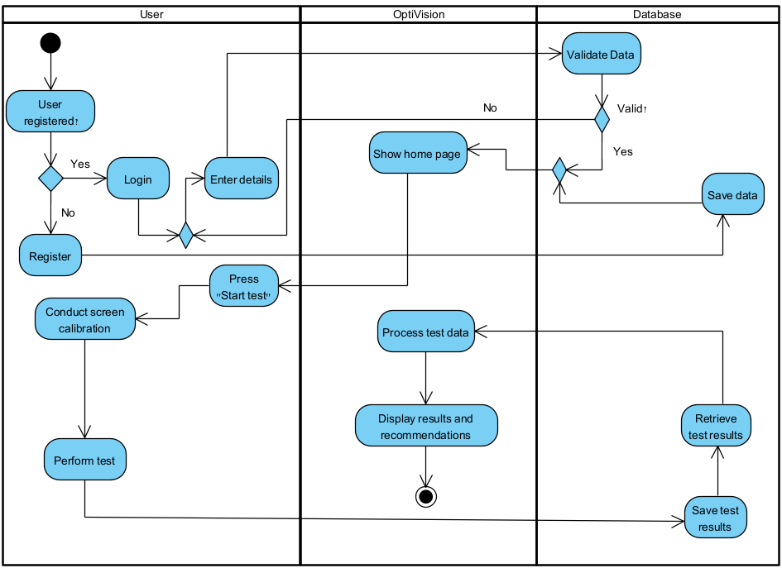The Activity Diagram delves into the operational flow within the OptiVision system. It maps out the sequential steps taken by the user and the system, from the initial user login to the final display of vision test results.

5.3.1 Activity Diagram

### 5.3.2 Class Diagram

The Class Diagram offers a detailed view of the static structure of the OptiVision system. It defines the key classes, their attributes, and methods, as well as the relationships between them.

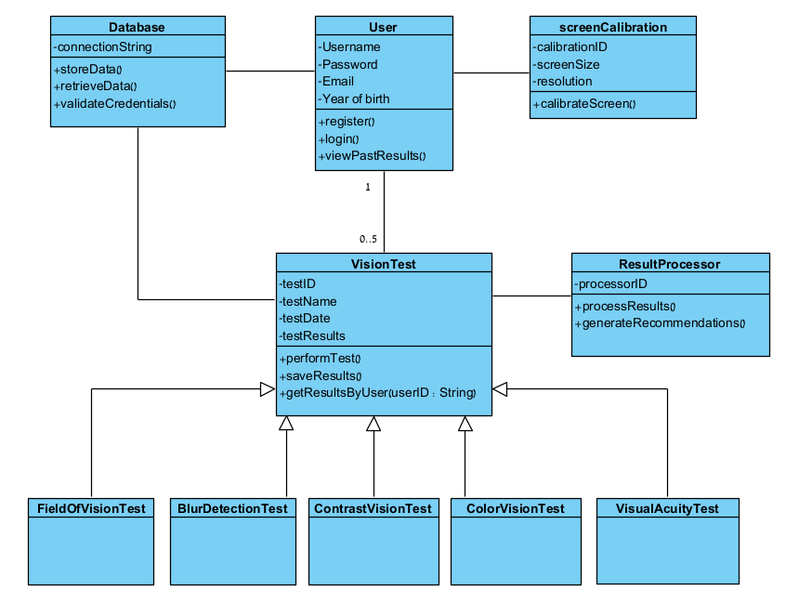

5.3.2 Class Diagram

### 5.3.3 Use-Case Diagram

The Use Case Diagram illustrates the various interactions between the users and the OptiVision system. It outlines the primary functions available to the user, such as registering, logging in, performing vision tests, and viewing past results.

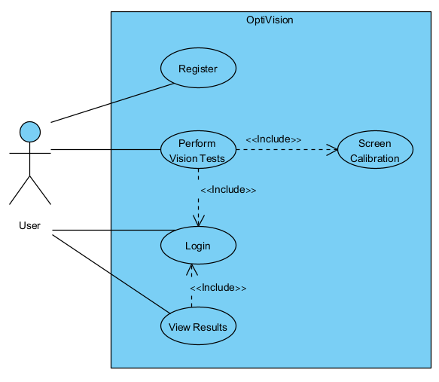

5.3.3 Use-Case Diagram

## 5.4 Algorithms:

### 5.4.1 Visual Acuity Test:

1. **Rank All Levels (1–17):**

Levels are ranked from 1 (easiest) to 17 (hardest), representing progressively smaller optotypes of the known Landolt C, a circle with a gap. In this test, the user identifies the gap's orientation (up, down, left, right). The test starts with the largest optotype and proceeds to smaller ones, simulating a clinical setting where visual acuity is tested using varying sizes of the Landolt C. This method provides an accurate measurement of the user's visual sharpness by determining the smallest gap they can accurately identify.

2. **Start the Test:**

The user begins at Level 1.

3. **Test Progression (Gradual and Accurate):**

Correct answer at Level 1:

* Move up by 2 levels to Level 3.

Correct answer at Level 3:

* Move up by 2 levels to Level 5 and continue progressing by 2 levels for each correct answer.

When the user reaches higher levels (after Level 10):

* Progress by 1 level at a time (e.g., Level 10 → Level 11 → Level 12).

4. **Incorrect Answer Handling (Precision-focused):**

First incorrect answer at any level:

* Drop down by 1 level (e.g., from Level 5 to Level 4).

Second incorrect answer:

* Drop another 1 level, ensuring the user gets a chance to correct mistakes and confirm their acuity level.

5. **Error Limits:**

The user is allowed 3 incorrect answers throughout the test. After the third mistake, the highest previously passed level is recorded as their final visual acuity.

6. **Vision Level Determination:**

The final vision level is determined by the highest accurately passed level.

Why This Version Is More Precise:

Gradual Progression:

Early levels move up by 2 levels for efficiency, but at higher levels (where precision is most important), the progression slows to 1 level at a time.

Error Correction:

By only dropping 1 level after a mistake, the algorithm ensures that users don’t unnecessarily drop too far, allowing for precise detection of their exact vision level.

Balanced Speed & Precision:

This algorithm sacrifices some speed for accuracy, ensuring the user is precisely tested at each critical level, especially in the higher levels where visual acuity diagnosis matters the most.

Tracking Correct Answers: For each correct response, the algorithm verifies if the user can distinguish smaller optotypes. If successful, the test progresses to the next level of difficulty.

Identifying Error Patterns: The algorithm monitors when errors begin to occur. If the user makes two mistakes at the same level, this indicates their visual limit is being reached.

Determining Final Result: Based on the highest level passed without significant errors and the error count, the algorithm determines the user’s visual acuity, reflecting their most accurate vision level.

### 5.4.2 The Contrast Test:

1. **Initialize Test Levels (1–17)**:
   * Arrange levels from 1 (easiest) to 17 (hardest), with each level representing progressively more challenging contrast sensitivity tests.
2. **Start the Test**:
   * Begin at Level 1, which has the highest contrast.
3. **Test Progression**:
   * If the user correctly identifies the contrast at any level, advance by 2 levels until reaching Level 10.
   * From Level 10 onwards, progress by 1 level at a time to increase precision.
4. **Incorrect Answer Handling**:
   * On the first incorrect response at any level, move down 1 level to allow for adjustment.
   * A second incorrect answer at the new level results in another step down by 1 level.
5. **Error Limits**:
   * Allow up to 3 incorrect answers before concluding the test. The highest level passed without error is recorded as the final score.
6. **Determine Final Visual Contrast Level**:
   * The highest level accurately passed indicates the user’s contrast sensitivity capability.

This approach ensures the test starts easy and becomes more challenging, fine-tuning the assessment of contrast sensitivity, especially at higher difficulty levels where precise measurement is crucial.

### 5.4.3 Color Vision Test:

1. **Setup Test Palette**:
   * Define a set of colors and shades to be used in the test, including common colors that are typically difficult for color vision deficient individuals to differentiate.
2. **Begin with Basic Colors**:
   * Start the test with primary colors (red, green, blue) to establish a baseline of the user’s color perception.
3. **Progress to Complex Shades**:
   * Gradually introduce more complex shades and combinations that require finer color discrimination.
4. **Interactive Testing**:
   * Present the user with multiple-choice questions where they must identify the color shown or match colors from memory.
5. **Error Adjustment**:
   * If a user fails to correctly identify a shade, present it again in a different context or alongside easier options to confirm if the mistake was an anomaly or part of a pattern.
6. **Adaptive Difficulty**:
   * Adjust the complexity of the test based on user performance to finely tune the assessment of their color vision abilities.
7. **Result Compilation**:
   * Analyze the answers to determine the type and severity of color vision deficiency, such as deuteranomaly (green-weak), protanomaly (red-weak), or tritanomaly (blue-weak).
8. **Provide Feedback and Recommendations**:
   * Offer insights into the user’s color vision and suggest further professional evaluation if necessary.

This algorithm ensures a thorough evaluation of color vision, adapting to the user's responses to accurately assess their ability to perceive and differentiate colors.

### 5.4.4 Blur Detection Test:

1. **Setup Instructions**:
   * The user is instructed to cover one eye and fix their gaze on a central point at arm’s length.
2. **Presentation of Stimuli**:
   * Display a semi-circle with lines radiating outward.
3. **User Response**:
   * Ask the user if all the lines appear to be the same shade of black and are uniformly visible.
4. **Repeat for Other Eye**:
   * Instruct the user to repeat the test with the other eye, ensuring both eyes are assessed.
5. **Analysis of Responses**:
   * Collect responses for both eyes. Any variation in the perception of the lines or shades might indicate an issue with uniform vision or potential blind spots.
6. **Recommend Further Testing**:
   * If inconsistencies or disturbances in vision are reported, recommend a more comprehensive examination by an eye care professional.

This simple test helps identify early signs of vision problems affecting specific parts of the visual field, which can be crucial for diagnosing conditions like glaucoma or retinal detachment.

### 5.4.5 Field of Vision Test:

1. **Setup and Instruction**:

* Instruct the user to cover one eye and fixate on the central dot from a specified distance, typically half an arm’s length.

1. **User Interaction**:

* The user is asked whether all lines and squares appear straight, aligned, and uniformly black without any distortion or blurred areas.

1. **Response Analysis**:

* Record the user’s response to determine if there are any anomalies such as waviness, blurring, or missing sections in the grid.

1. **Repeat for the Other Eye**:

* Conduct the same test with the other eye to ensure both eyes are assessed individually.

1. **Evaluate Results**:

* Compare the responses for each eye. Any irregularities may suggest issues with the retina or optic nerve that could require further medical evaluation.

1. **Recommendation**:

* If any distortions are detected, recommend a comprehensive eye examination by a professional to explore underlying causes.

## 5.5 Screen Calibration:

The calibration ensures that the letters on the screen are scaled to simulate their actual size if viewed from a 40 cm distance. Proper calibration helps ensure that the user’s results reflect a real-world equivalent of their vision clarity, as the size and distance are both optimized for standard eye testing conditions. Output: A correctly calibrated screen optimized for a viewing distance of 40 cm, or a warning about reduced test accuracy. Why this calibration is important: Visual acuity tests are typically designed to assess a user’s ability to distinguish shapes or letters at a set distance (usually 40 cm for near vision tests). Ensuring that the screen is calibrated properly ensures that the size of the optotypes (the symbols) displayed on the screen corresponds accurately to what would be used in a clinical setting. Calibration also ensures that variations in monitor size and resolution are accounted for, so the test can deliver accurate results when viewed from approximately 40 cm away.

Here's how we will do it:  
**Measurement Reference:** The calibration process begins by asking the user to place a standard-sized object, like a credit card or ID card, against the screen. This serves as a reference for the actual size.

**Slider Adjustment:** The user adjusts a slider on the screen until the on-screen representation matches the real-world size of the card. This aligns the screen’s virtual measurements with physical measurements.

**Calculation:** The system then calculates the pixel-to-physical size ratio using the card’s dimensions and adjusts the display parameters accordingly.

**Validation:** After calibration, a confirmation step ensures that the displayed optotypes correspond to the intended size for a 40 cm viewing distance. If discrepancies are detected, a warning is shown about potential accuracy issues.

# 6. Evaluation

The evaluation of the OptiVision system will focus on ensuring that all components of the system function correctly, provide accurate results, and deliver a seamless user experience. This evaluation will be divided into three main areas: System Functionality, User Experience, and Vision Test Accuracy.

## 6.1 System Functionality

We will conduct extensive testing to verify that the OptiVision application performs all intended functions reliably. This includes:

* **Input Hardware:** Testing will ensure that the application correctly interacts with hardware components such as the monitor (for display calibration), mouse, and keyboard. These tests will be conducted manually to confirm that each hardware input is properly recognized and utilized by the application.
* **Desktop Application (PC App):** The core functionalities of the PC App, such as screen calibration, performing vision tests, saving results, and retrieving past results, will be thoroughly tested. We will use both manual testing and automated testing tools where applicable to ensure that the application is stable and performs all operations without errors.
* **Database Interaction:** We will test how the application interacts with the database, focusing on the storage, retrieval, and validation of data. This includes ensuring that user credentials are securely stored, test results are correctly saved, and past results can be accurately retrieved.

## 6.2 User Experience

The evaluation will also consider the overall user experience provided by the OptiVision system. This will involve:

* **Interface Usability:** Testing the usability of the interface, ensuring that users can easily navigate through the application, perform vision tests, and view their results. We will gather feedback from test users to identify any areas where the interface can be improved.
* **Performance:** Assessing the performance of the application, including page load times and responsiveness, to ensure a smooth experience. For instance, key operations such as loading the home page, accessing test pages, and displaying results should be completed quickly and without delays.
* **Accessibility:** Ensuring that the application is accessible to all users, including those with varying levels of technical proficiency. This includes testing for clear instructions, easy navigation, and providing helpful prompts or messages where needed.

## 6.3 Vision Test Accuracy

We will validate the accuracy of the vision tests offered by the OptiVision system by comparing the results against established benchmarks. The goal is to ensure that the tests provide reliable assessments of users’ vision health. This evaluation will include:

* **Visual Acuity Test:** Comparing the results from the application’s visual acuity test with standard measures to ensure accuracy in detecting issues such as myopia or hyperopia.
* **Color Vision Test:** Ensuring that the color vision test accurately identifies common color vision deficiencies, such as red-green color blindness.
* **Contrast Sensitivity Test:** Verifying that the contrast sensitivity test provides reliable results that can help detect issues like cataracts or other conditions affecting contrast perception.
* **Blur Detection Test:** Confirming that the blur detection test accurately identifies problems with visual sharpness, potentially indicating refractive errors.
* **Field of Vision Test:** Checking that the field of vision test reliably assesses peripheral vision, helping to identify issues like glaucoma or other conditions that affect the edges of the visual field.

|  |  |  |  |
| --- | --- | --- | --- |
|  | Module | Tested function | Expected results |
| 1 | Input Hardware | |  | | --- | | Access Monitor for Calibration |  |  | | --- | |  | | |  | | --- | | Correct screen calibration |  |  | | --- | |  | |
| 2 | Input Hardware | |  | | --- | | Access Mouse |  |  | | --- | |  | | |  | | --- | | Receive mouse input |  |  | | --- | |  | |
| 3 | Input Hardware | Access Keyboard | Receive keyboard Input |
| 4 | |  | | --- | | Desktop App |  |  | | --- | |  | | |  | | --- | | Screen Calibration |  |  | | --- | |  | | |  | | --- | | Accurate calibration based on real-world objects |  |  | | --- | |  | |
| 5 | Desktop App | |  | | --- | | Perform Vision Test |  |  | | --- | |  | | |  | | --- | | Vision test runs without errors |  |  | | --- | |  | |
| 6 | Desktop App | |  | | --- | | Show Results |  |  | | --- | |  | | |  | | --- | | Displays test results accurately |  |  | | --- | |  | |
| 7 | Desktop App | |  | | --- | | Save Test Results |  |  | | --- | |  | | |  | | --- | | Test results are saved to the database |  |  | | --- | |  | |
| 8 | Desktop App | |  | | --- | | Retrieve Past Results |  |  | | --- | |  | | |  | | --- | | Retrieves past test results from the database |  |  | | --- | |  | |
| 9 | |  | | --- | | Desktop App |  |  | | --- | |  | | |  | | --- | | Login Functionality |  |  | | --- | |  | | |  | | --- | | User can log in with correct credentials |  |  | | --- | |  | |
| 10 | |  | | --- | | Database Interaction |  |  | | --- | |  | | |  | | --- | | Store User Data |  |  | | --- | |  | | |  | | --- | | User data is stored correctly in the database |  |  | | --- | |  | |
| 11 | |  | | --- | | Database Interaction |  |  | | --- | |  | | |  | | --- | | Validate User Data |  |  | | --- | |  | | |  | | --- | | User login data is validated against the database |  |  | | --- | |  | |
| 12 | |  | | --- | | Database Interaction |  |  | | --- | |  | | |  | | --- | | Save Test Results |  |  | | --- | |  | | |  | | --- | | Test results are stored in the database |  |  | | --- | |  | |
| 13 | |  | | --- | | Database Interaction |  |  | | --- | |  | | |  | | --- | | Retrieve Test Results |  |  | | --- | |  | | |  | | --- | | Retrieves correct test results from the database |  |  | | --- | |  | |
| 14 | |  | | --- | | Vision Test Accuracy |  |  | | --- | |  | | |  | | --- | | Visual Acuity Test |  |  | | --- | |  | | |  | | --- | | Visual acuity test results match standard benchmarks |  |  | | --- | |  | |
| 15 | |  | | --- | | Vision Test Accuracy |  |  | | --- | |  | | Color Vision Test | Color vision test results are accurate |
| 16 | |  | | --- | | Vision Test Accuracy |  |  | | --- | |  | | |  | | --- | | Contrast Sensitivity Test |  |  | | --- | |  | | |  | | --- | | Contrast sensitivity test is reliable |  |  | | --- | |  | |
| 17 | |  | | --- | | Vision Test Accuracy |  |  | | --- | |  | | Blur Detection Test   |  | | --- | |  | | |  | | --- | | Blur detection test produces accurate results |  |  | | --- | |  | |
| 18 | |  | | --- | | Vision Test Accuracy |  |  | | --- | |  | | |  | | --- | | Field of Vision Test |  |  | | --- | |  | | Field of vision test results are consistent |

This evaluation plan ensures that the OptiVision system is not only functionally robust and accurate in its vision assessments but also provides a user-friendly experience. The comprehensive testing of hardware interactions, application performance, and the accuracy of the vision tests will help ensure that the system meets its intended purpose of providing reliable and accessible vision health assessments.

# 7. References

## 7.1 GitHub Link:

<https://github.com/TameerAmer/Capstone-Project.git>

## 7.2 Academic References:

**[1]** Elliott, D. B., & Flanagan, J. G. (2013). Assessment of visual function in the early detection of vision impairment. Ophthalmic & Physiological Optics, 33(2), 133-139.

**[2]** Adams, C. S., & Bennett, J. L. (2017). The effectiveness of computer-based visual acuity testing: A review. Optometry & Vision Science, 94(5), 450-457.

**[3]** Verriest, G. (2005). Screening for congenital color vision deficiencies in school children: principles, methods, and applications. Ophthalmic & Physiological Optics, 25(1), 139-149.

**[4]** Regan, D., & Neima, D. (2010). Low-contrast letter charts and sine-wave grating tests in ophthalmological practice and research. Clinical Vision Sciences, 5(3), 235-250.

**[5]** McKean-Cowdin, R., Varma, R., Wu, J., Hays, R. D., & Azen, S. P. (2011). Impact of visual impairment on health-related quality of life in Latinos: The Los Angeles Latino Eye Study. Ophthalmology, 115(10), 1756-1763.

**[6]** Ekpenyong, B., & Antia, U. (2018). An evaluation of the accuracy of online vision screening tools. Journal of Telemedicine and Telecare, 24(9), 602-607.

**[7]** Griffin, J. R., & Grisham, J. D. (2012). Binocular anomalies: Diagnosis and vision therapy. Elsevier Health Sciences.

**[8]** Carkeet, A., & Lee, S. (2015). Evaluating the efficacy of screen calibration in online vision testing platforms. Journal of Vision, 15(12), 589-596.

**[9]** Stewart-Brown, S. L., & Snowdon, S. K. (2013). Severity of vision impairment in children and its impact on educational outcomes. British Journal of Educational Psychology, 85(3), 317-329.

**[10]** Porcar, E., & Montés-Micó, R. (2007). Screening for visual problems in school-age children: A review. Journal of Optometry, 1(2), 57-65.

**[11]** ChatGPT – used as assistance in writing and refining the project book, provided responses to prompts such as "can you expand the following paragraph:". <https://openai.com/chatgpt>